ECOMMERCE SALES ANALYTICS USING POWER BI

1. Introduction
Ecommerce Sales Analytics is a data analysis project developed using Microsoft Power BI. The main purpose of this project is to analyse ecommerce sales data and understand business performance through interactive dashboards and visualisations.
The project focuses on analysing important business metrics such as total sales, total profit, number of orders, customer count, product categories, regional performance and monthly sales trends.
Using Power BI, the raw sales data is transformed into meaningful visual insights that help identify sales patterns, understand customer behaviour and evaluate business performance. Interactive charts and filters allow users to explore the data based on different categories, regions and months.
This project demonstrates how data visualisation and analytics can support better business decision-making.

2. Project Objectives
The main objectives of this project are:
- To analyse ecommerce sales data and understand overall business performance.
- To calculate important business metrics such as total sales, total profit, total orders and total customers.
- To identify the best-performing product categories and regions.
- To analyse monthly sales trends and identify sales patterns.
- To compare sales and profit across different cities and product categories.
- To create an interactive dashboard using Microsoft Power BI.
- To present meaningful insights that support data-driven business decisions.

3. Tools and Technologies Used
The following tools and technologies were used to develop this project:
1. Microsoft Excel
- Used to store and organise the ecommerce sales dataset.
- Provided the source data for analysis.
2. Microsoft Power BI
- Used to create interactive dashboards and visualisations.
- Used to analyse sales, profit, orders and customer data.
3. Power Query
- Used for data importing, cleaning and transformation.
- Helped prepare the dataset for analysis.
4. Data Visualization
- Used charts, graphs, KPI cards and slicers to present business insights in an understandable format.

4. Dataset Description
The project uses an Ecommerce Sales Dataset containing information about customer orders, products, sales, profit and geographical regions.
The dataset includes the following fields:
Field Name | Description
Order_ID | Unique order identification
Customer_ID | Customer identification
Order_Date | Date of the order
Category | Product category
Region | Geographical sales region
City | Customer city
Sales | Total sales amount
Profit | Profit earned from the order
The dataset was imported into Microsoft Power BI for data preparation, analysis and dashboard development.

5. Data Cleaning and Preparation
The ecommerce sales dataset was imported into Microsoft Power BI and prepared for analysis.
The following preparation steps were carried out:
- Imported the Excel dataset into Power BI.
- Checked the dataset columns and their data types.
- Verified the sales, profit and order date fields.
- Prepared the data for creating charts and visualisations.
- Used Power Query to organise and transform the data where required.
These steps helped prepare the dataset for accurate analysis and dashboard development.

6. Dashboard Development and Visualizations
An interactive Ecommerce Sales Analytics Dashboard was developed using Microsoft Power BI to present important business information in a visual format.
The dashboard contains the following components:
6.1 Key Performance Indicators (KPIs)
Four KPI cards were created to display:
- Total Sales
- Total Profit
- Total Orders
- Total Customers
6.2 Charts and Visualizations
The following charts were created:
- Sales by Category – Displays sales performance across different product categories.
- Sales by Region – Shows the contribution of different geographical regions to total sales.
- Monthly Sales Trend – Represents sales performance over different months.
- Profit by Category – Compares profit earned across product categories.
- Sales by City – Displays sales performance across different cities.
6.3 Interactive Filters (Slicers)
The dashboard includes interactive slicers for:
- Region
- Category
- Month
These slicers allow users to filter the dashboard and explore specific business information.

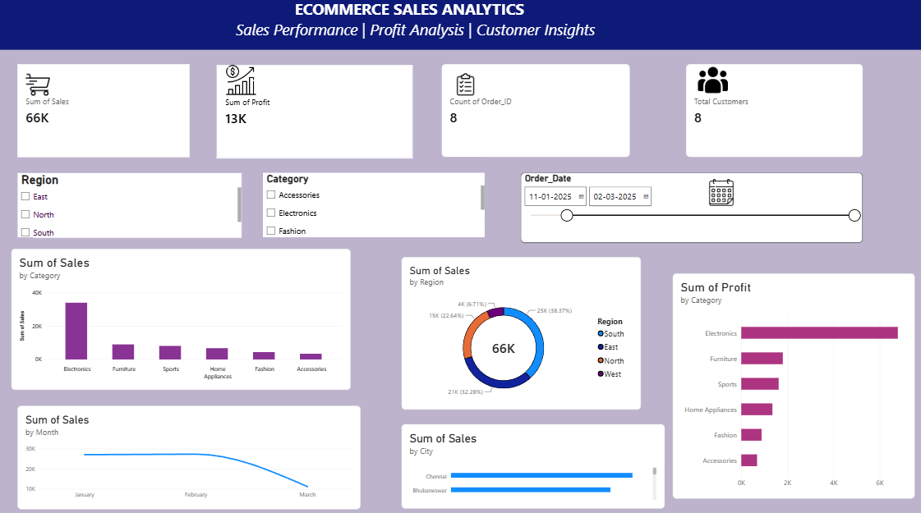

7. Business Insights and Findings
Based on the Ecommerce Sales Analytics Dashboard, the following observations were identified:
- Sales Performance: The dashboard displays total sales of approximately 39K.
- Profit Performance: The total profit is approximately 8K.
- Category Analysis: Electronics is the leading product category in sales.
- Regional Analysis: The South region contributes the largest share of sales in the displayed dashboard.
- Monthly Analysis: February shows the highest sales among the displayed months.
- City Analysis: Chennai shows strong sales performance compared with the other displayed cities.
These insights help understand business performance, identify successful product categories and regions, and recognise sales trends.

8. Conclusion
The Ecommerce Sales Analytics project successfully demonstrates the use of Microsoft Power BI for analysing and visualising ecommerce sales data.
Through interactive KPI cards, charts and slicers, the dashboard provides a clear overview of sales, profit, customer activity, product categories and regional performance.
This project helped develop practical knowledge of data preparation, data visualisation and business analysis using Excel, Power Query and Power BI.
Overall, the project demonstrates how data analytics can transform raw business data into meaningful insights that support informed decision-making.

